Sediment balance of the Vistula Lagoon
Vladimir Chechko, Atlantic Branch of P.P.Shirshov Institute of Oceanology of Russian Academy of Sciences, che-chko@mail.ru
Boris Chubarenko, Atlantic Branch of P.P.Shirshov Institute of Oceanology of Russian Academy of Sciences, chuboris@mail.ru

Abstract. Vistula Lagoon is the second largest lagoon in the Baltic Sea with maximum depth 5.2 m and average depth 2.7 m. Water volume and area are 2.3 km³ and 838 km². Lagoon is connected with the Baltic Sea by single inlet 400 m wide and 10-12 m deep. Sediment budget estimation were made using literature sources, results of field measurements (hydrology, suspended sediment content, upper layer sediment structure, direct measurements of sedimentation in summer and winter conditions). The budget for terrigene and biogenic components of sediments were made, considering their contributions from the rivers, inflow from the Baltic Sea, coastal erosion and aerial flux, biological production within the lagoon, totally - ca. 730 thousands ton per year. Nearly half of total gain is washed out (105 and 244 thousands ton per year of terrigene and biogenic components), another half is dissolved and mineralized (biogenic component), and only 10% is deposited on the bottom, resulting in rather low sedimentation rate - 0.4 mm/year during last 100 years. Paper explain the reason of difference with estimation made in (Chubarenko&Chubarenko, 2002) and concludes that the clarification of estimates of the amounts of sediments transported from the lagoon to the Baltic Sea is a critical element for understanding the evolution of the Vistula Lagoon as a sedimentation system.

I. Introduction.
Lately the modern sediment accumulation processes in the coastal zone of the sea receives close attention of researchers. This is mainly explained by great interest towards the offshore strip due to construction of industrial facilities in this area, construction of ports, navigation channels, creation of new recreation areas, development of coastal navigation and fishing, intensive use of mineral and biological resources.
Multiple economic use facilities also include the Vistula Lagoon – the biggest shallow (maximum depth 5.2 m, average – 2.7 m) lagoon-type basin of the Baltic Sea located in its south-eastern part (Fig. 1). The lagoon is separated from the sea by a narrow sand spit, and water exchange with the sea is achieved through the navigable Strait of Baltiysk (in some studies – the Baltiysk Strait). Kaliningrad Seaway Canal with intensive year-round navigation passes along its northern shore, lagoon water area is actively used for fishing and production of nonmetallic mineral resources. In the recent years the lagoon is becoming more and more significant as a recreation zone. All these factors, without a doubt, increase the anthropogenic load on water body and require intensification of studies of all components of the aquatic ecosystem, especially the structure and more of anthropogenic flows for development of an effective environment control model.

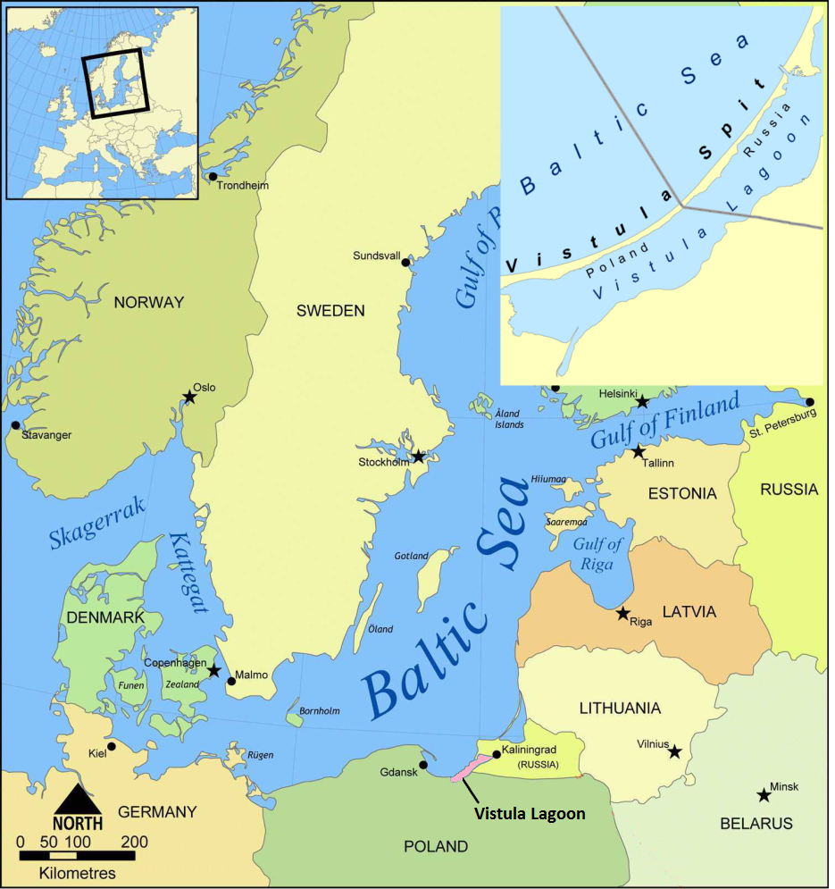
Fig. 1. Location of the Vistula Lagoon in the South-Eastern Baltic.

Because of this there is an important objective of determination of the main sources of sedimentation material in delivery of its individual components, as well as assessment of the absolute weight of the sedimentation material coming in the water body and depositing on its bottom. Extensive factual material accumulated in the course of more than twenty years of studies of the coastal systems by Atlantic Branch of P.P. Shirshov Institute of Oceanology allows for calculation of the sedimentation material balance in the Vistula Lagoon, which is the goal of this paper.
Therefore we should mention that the first attempt of balance calculation of the sedimentation material in the Vistula Lagoon took place earlier [1]. However it did not consider all elements, and some of them require clarification and supplementation.

II. Methods.
Overall, sedimentation balance method developed by the scientific school [2,3,4] was used for achievement of the set objective. Individual elements of the sedimentation material balance were calculated using well known methods currently used in oceanology research.
Water suspension was extracted to determine its concentration and composition using membrane ultra-filtering method with gravimetric estimation of the quantity of suspended matter deposited on the filter [5, 6]. Water samples were filtered in vacuum with -0.6 atmospheres through pre-weighted nuclear filters 47 mm in diameter with pore size 0.45 mcm. After filtration of water filters were flushed in bidistillate, placed in clean Petri dishes, dried down to constant weight in a desiccator. Suspended matter content was determined by weighting with 0.1 mg precision using analytical scales. Weight of the matter on a filter attributed to the filtered water volume gave the total concentration of suspended matter (mg/l). Overall, over 1000 determinations of suspended matter concentration was made in water samples taken during the period from 1992 to 2013 in the lagoon, the Strait of Baltiysk and mouths of rivers.
In order to determine the total organic matter and the suspension (234 determinations between 1992-2013) the water was filtered through fiberglass GF/F filters heat treated under 450–480°С, which were dried, weighted and heat treated again in a muffler at 540°С. After cooling down and achievement of constant weight in a desiccator they were weighted again, and the ratio of mineral and organic components in the sample was determined from the weight difference [7].
To determine the organic carbon (C_{org}) content the water sample was filtered through fiberglass GF/F filters with subsequent determination of C_{org} using express-analyzer AN-7529 with automatic titration by pH value. In total 56 determination were made in the Laboratory of Geology of the Atlantic of AO IO RAS (analytic researcher – N.G. Kudryavtsev).
Eolian material arriving in the lagoon waters in summer was collected using nylon nets entrapping particles due to an electrical charge [8, 9]. A floating trap designed by the author was used as net carrier [10]. Eolian material accumulated in the snow coating of the lagoon was collected and studied using methods accepted in studies of Arctic aerosols [11]. Between 2006 and 2013 a total of 124 samples of eolian material were analyzed.
Sedimentation in the lagoon was studied using method developed by S.N. Antsyferov [12] that is based on entrapment of settling sediments by accumulating traps. To achieve this objective during ice formation the bottom-based sedimentation trap method was used [13]. This method is based in direct catching of the material quantity sedimenting over a certain period inside the trap with known diameters placed on the water body bottom. Total of 164 sedimentation material samples bottom-based sedimentation traps were studied between 1993 and 2011.

Analysis of river run-off and suspended substance from rivers falling in the lagoon was performed in 1999-2000 using methods based on instrumental measurements of stream velocities and determination of water suspension concentration [14]. The collected date was subsequently compared to reference data, and average values calculated.
Calculation of the lagoon balance elements has also used reference data published in a number of well-known papers mentioned below.

III. Results and discussion
In order to identify the main trends of the modern sedimentation process it is important to know ratios of sedimentation material entering the water body from various sources. Based on the field observations and literature data we have calculated the absolute weights of the material entering the lagoon and leaving it. Calculation results and determined main sedimentation material balance elements are summarized in Table 1.
From the analysis of data presented in this table we can make a conclusion that the vast majority of the terrigene matter enters the lagoon as suspended solids with river runoff (68.8 thousand t/year). Considering the bedload sediments (4 thousand tons), the annual amount of terrigene material arriving the lagoon with river runoff is 72.3 thousand tons (58%).
There is a total of 10 rivers and creeks falling into the Vistula Lagoon with the total annual runoff water volume of 3.67 km³. According to [15, 16], 44% of the total runoff comes from the Pergola River, and the rest – from small rivers. According to the literature and own data [16, 17, 18, 19], the water turbidity in the rivers falling into the Vistula Lagoon varies between 2.2 and 76.4 mg/l with the average of 27.2 mg/l. In this case the annual runoff of suspended solids in the lagoon water (including the bedload) will be 103.5 thousand tons per year on average.

The principal position in the lagoon’s water balance holds water exchange through the Strait of Baltiysk. The total annual inflow from the sea is equal to 16.99 km³, i.e. four times the runoff from the lagoon catchment. According to [20, 21, 22] and own observation, water suspension concentration in lagoon-adjacent coastal area of the sea varies from 1.2 to 12.8 mg/l (4.4 mg/l on average). Based on this, the annual transfer of suspended and transported deposits from the sea to the lagoon is 76.5 thousand tons. Terrigene material (including bedload) accounts for about 40% (30.1 thousand tons) of this amount, and biogenic material – for 60 % (45.9 thousand tons).
Results of the water suspension studies in the lagoon during offshore currents (water going from the lagoon to the sea) show that its average concentration was 17 mg/l. Therefore the quantity of suspended sedimentary material transferred from the lagoon to the sea in a year is 348.4 thousand tons. And the biggest part (243.9 thousand tons or 70 %) is formed by the biogenic suspended matter.

Eolian deposits, bank and bottom erosion products are estimated by us at 23 thousand tons (17 %) per year. However after more detailed studies this value might go up.
Therefore, the total amount of terrigene material entering the lagoon every year is 125.4 thousand tons.
As far as inflow of the organic matter is concerned, most of it (525 thousand tons or 87.1 %) is composed by autochthonic biogenic products [23, 24]. According to our own observations, river runoff brings 31.2 thousand tons (5.2%) of biogenic material to the lagoon every year, and water exchange with the sea – 45.9 thousand tons (8.0 %). The resulting total amount of the biogenic material produced in the lagoon and being transported to it is 603.1 thousand tons per year.

Outgoing part of the terrigene material balance is composed by bottom sedimentation and transfer to the sea. Calculations show that the majority of terrigene material (104.5 thousand tons or 83.3%) is carried through the strait to the sea. So far we were not able to separately assess the sedimentation balance component describing integral sedimentation of matter in the lagoon due to constant wind and current induced resuspension and re-deposition of the sediments. Therefore, just as in [1], this component was assessed from the assumption of closeness of the entire balance in a year – only 20.9 thousand tons (16.7 %) of the sedimentation material is deposited on the bottom.
243.9 thousand tons of biogenic material is transported to the sea, and only insignificant part is deposited on the bottom. In spite of relatively high biological productivity of the lagoon, the average organic carbon content is 1.3 %. Therefore bottom deposits every year receive 8.3 thousand tons of water suspended biogenic material. Vast majority (350.9 thousand tons or 58 %) of it goes for dissolution and mineralization, as well as consumption by various food chain links.
Earlier the same method was used to prepare the sedimentation material balance of the Couronian Lagoon [25]. It is interesting to compare certain components of balances of the two lagoons located in the same geographic region. Thus, average annual river runoff to the Vistula Lagoon is 3.67 km³, which is about 6 times less than the river runoff to the Couronian Lagoon (23.1 km³). The average seawater inflow in the Vistula Lagoon is 17.0 km³, which is 3.3 times less than the salt water inflow in the Couronian Lagoon (5.1 km³) (see Fig. 2) I.e., ratio of annual volumes of fresh and salt water entering the lagoons is 1:4.6 for the Vistula Lagoon and 4.5:1 for the Couronian Lagoon, which allows to consider them as coastal waters with mainly marine (Vistula Lagoon) and river (Couronian Lagoon) influence.
Predominance of marine and river influence has a different effect of the sedimentation material quantity entering the lagoon and leaving it. The majority of suspended terrigene material (87%) enters the Couronian Lagoon (river influence dominant) with river runoff, and only 1.6% with seawater. The situation in the Vistula Lagoon (marine influence dominant) is somewhat different. Here 24% of terrigene sedimentation material comes to the water body with seawater, and not more than 58% - with river runoff (Illustration 2). And the majority (84%) of the terrigene sedimentation material entering the Vistula Lagoon is carried out to the sea, and only 16% is deposited on the bottom. At the same time, the majority of the material entering the Couronian Lagoon us deposited on the bottom (74%), and only up to 26% is carried out to the sea. Eventually, this affect the rate of modern deposition of sediments, which on average is 0.4 mm/year [26] for the Vistula Lagoon, i.e. 3.5 times less than for the Couronian Lagoon (1.4 mm/year).

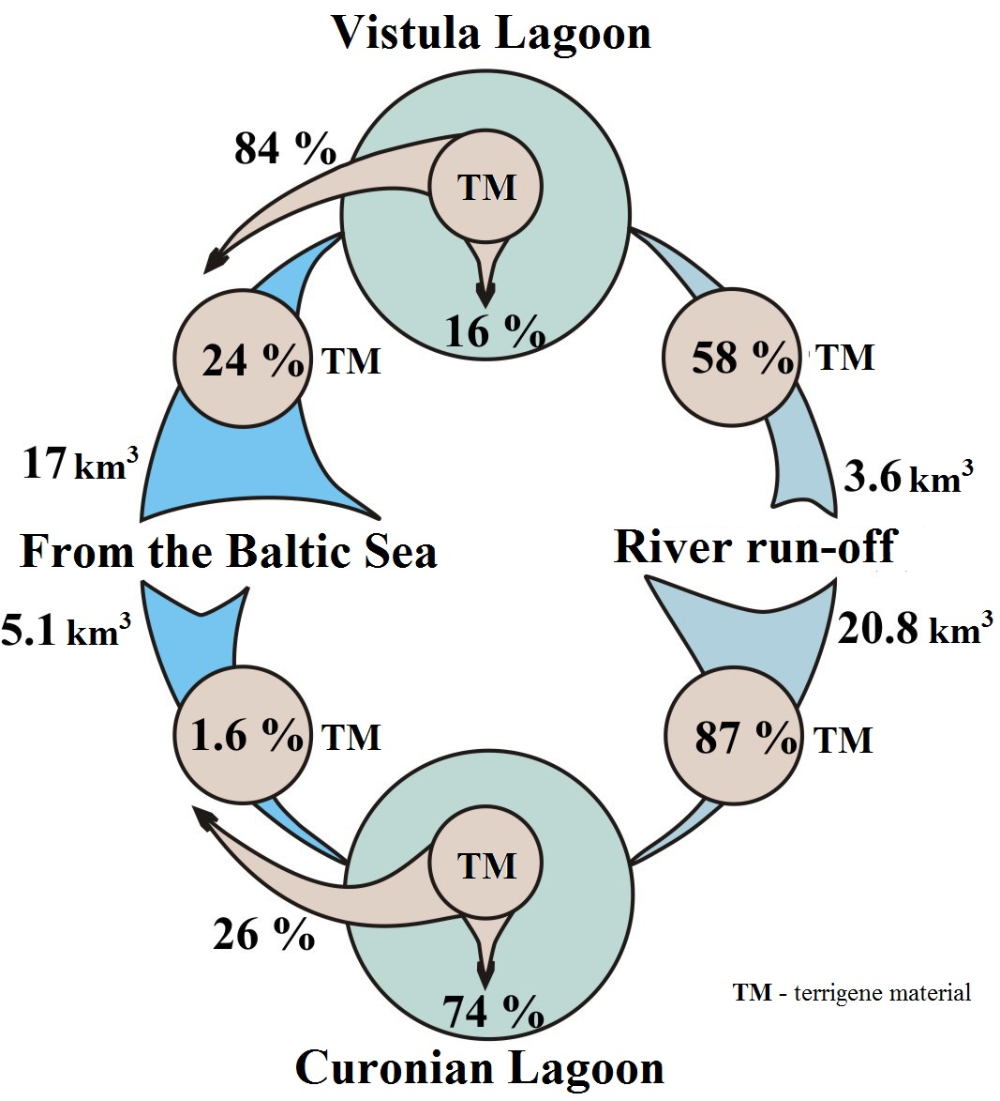
Fig. 2. Water gain and amounts of terrigene material entering the Couronian and Vistula lagoons.

In conclusion we would like to comment on comparison of the results of this study with the balance estimates in [1]. For the water balance our analysis and analysis in [1] rely on the same data [16]. [1] included balance assessment only for the inorganic part of the material, while this article offers significant clarification of the suspension concentration and its separation into the terrigene and biogenic parts, allowing for separate determination of balances for both of these components of the sedimentation material.
In [1] the calculation of terrigene material outflow from the lagoon to the Baltic Sea uses the average suspension concentration value in the lagoon itself (15.7 mg/l, [27]), while this analysis uses the terrigene suspension concentration value in the outflowing water according to the direct measurements in the Strait of Baltiysk – on average 5.1 mg/l. As a result, estimates of the terrigene material transported from the lagoon in a year differ by the factor of 3 (104.5 and 322.164 [1] thousand tons per year), resulting in different conclusions: [1] assumed there is no material accumulation in the entire lagoon, while our estimates give only low values of deposition of sediments in the lagoon – 29.2 thousand tons per year.
Therefore, the question of estimating the amount of sedimentation material transported from the lagoon through water exchange with the sea remains the key issue, end it will be the subject of further research.

IV. Conclusions.
The calculations show that the absolute weights of the terrigene sedimentation materials in the Vistula Lagoon are formed mainly by river runoff (72.3 thousand tons) and water exchange with the sea (30.1 thousand tons). And 83% of all the incoming terrigene material is transported to the sea, only up to 17% of it is deposited on the bottom.
High productivity of phytoplankton is responsible for inflow of the biogenic material. Its total inflow in the Vistula Lagoon is more than 4 times higher than the terrigene material inflow. However most of the biogenic material is dissolved, mineralized and transported to the sea. Only a small part of it is deposited on the bottom (about 1.5% of the incoming amount).
Annual flow rate of the total sedimentation substance from the lagoon water volume is 728.5 thousand tons, 350.9 thousand tons of which is dissolved, mineralized and consumed by different organisms, 348.4 thousand tons is transported to the sea, and 29.2 thousand tons is deposited on the lagoon bottom. Comparison of the amount of incoming terrigene (125.4 thousand tons) and biogenic (603.1 thousand tons) material demonstrates predominance of biogenic processes and high rates of organic matter production. However only a small part of it is deposited on the bottom of the lagoon. Terrigene process of modern sediments deposition is predominating in the Vistula Lagoon and in the Baltic Sea in general. Contribution of the biogenic material is mainly limited to life support of organisms and the biogeochemical cycle.
In the Vistula Lagoon, unlike the Couronian Lagoon, majority (84%) of incoming terrigene sedimentation material is further transported to the sea, and only 16% is deposited on the bottom; at the same time, majority of the material entering the Couronian Lagoon is deposited on the bottom (74%), and only up to 26% is transported out to the sea.
In a conclusion we can say that the calculated elements of the sedimentation balance of the Vistula Lagoon indicate low rate of sediments deposition currently observed in the lagoon and that in the future it is not threatened by shallowing and siltation. Also we can presume that there is a natural self-cleaning mechanism operating in the lagoon, which transports large volumes on thin sedimentation material from the lagoon to the sea together with various pollutants.
More detailed estimates of the sedimentation balance performed in this article significantly clarify the balance ratios discussed in [1], and show that the clarification of estimates of the amounts of sediments transported from the lagoon to the Baltic Sea is a critical element for understanding the evolution of the Vistula Lagoon as a sedimentation system.

V. Acknowledgement
Data collection was made under support of the theme № 0149-2014-0017 of State Assignment of the P.P.Shirshov Institute of Oceanology of the Russian Academy of Sciences (2015-2017). Preparation of this article was made under the support of the Project No 14-17-00547 “A forecast development for evolution of accumulative Russian coasts of tideless seas”.
VI. References

1. Chubarenko B.V., Chubarenko I.P. “New way of natural geomorphological evolution of the Vistula Lagoon due to crucial artificial influence,” in Geology of the Gdansk Basin, Emelyanov E.M. (ed.), Kaliningrad: Yantarny Skaz, 2002, pp. 371-374. In Russian.
2. Strakhov N.M. “Towards understanding of relationship and mechanisms of marine sedimentation of the Black Sea,” Transacts of USSR Academy of Sciences, Geological Series, 1947, No 2, pp. 49090. In Russian.
3. Strakhov N.M. Essays in carbon accumulation in modern water basins. In For the memory of Academician A.D.Arkhangelsky, Moscow: Publisher of USSR Academy of Sciences, 1951, pp. 487-567. In Russian.
4. Strakhov N.M., Brodskaya N.G., Knyazeva L.M., Razhivina A.M., Rateev M.A., Sapozhnikov D.G. Sediment formation in nowadays water basins. Moscow: Publisher of USSR Academy of Sciences, 1954, 792 p. In Russian.
5. Lisitsyn A.P. Methods of collection and investigation of water suspended sediments for geological purposes. Proceedings of the Institute of Oceanology of USSR Academy of Sciences. 1956, Vol. 19, pp. 204-231. In Russian.
6. Bogdanov Yu.A., Lisitsyn A.P. “Distribution and content of suspended organic matter in the waters of Pacific Ocean,” Oceanological Studies, No 18, pp. 75-155, 1968. In Russian.
7. Vitiuk D.M. Suspended matter and its biogenic components. Kiev: Naukova dumka, 1983, 212 p. In Russian.
8. Chester R., Johnson L.R. “Atmospheric dusts collected off the West African coast,” Nature. Vol. 229, pp 105-107, 1971.
9. Zhivago V.N., Bogdanov Yu. A. Hydrophysical and hydrooptical studies in the Atlantic and pacific oceans. Moscow: Nauka, 1974, pp. 259-279. In Russian.
10. Chechko V.A., Kurchenko V.Yu. Study of the fluxes of aerosol by floating trap. Meteorology and Hydrology, № 11, pp. 85-90, 2008. In Russian.
11. Shevchenko V.P. The influence of aerosol on environment and marine sediment accumulation in the Arctic. Moscow: Nauka, 2006, 226 p. In Russian.
12. Antsyferov S.M. The method to determine the suspended sediments concentration in the upper part of shelf. Moscow: Institute of Oceanology, 1987, 64 p. In Russian.
13. Semenovich N.I. Bottom sediments of the Lake Ladoga. Moscow: Nauka, 1966, 55 p. In Russian.
14. Shamov G.I. River sediemnts. Leningrad: HydrometeoIzdat. 1955, 380 p. In Russian.
15. Mikulski Z. Bilans wodny zalewow przybaltyckich // Wind. Sluzby Hydr. i Met., 59a. -Warszawa, 1964
16. Hydrometeorological Conditions of the Vistula Lagoon, N.N. Lazarenko and А. Maevsky, Eds. Leningrad: Hydrometizdat, 1971, 330 p. In Russian.
17. Pustelnikov O.S. Geological characteristics of the basin and mechanism of sediment formation in the Baltic Sea. Synopsis of thesis PhD in Geological-mineralogical studies. Vilnius, 1974, 22 p. In Russian.
18. Blazhchishin A.I. The balance of sediments in the Gdansk basin of the Baltic Sea. Lithology and Mineral Resources, № 5, pp. 67-76, 1984. In Russian.
19. The role of sediment flows from the Pregolya River and other rivers in the sediment balance of the Vistula Lagoon: Sci. Report. Kaliningrad: Atlantic Branch of P.P.Shirshov Institute of Oceanology of Russian Academy of Sciences. 2000. 20 p. In Russian.
20. Emelyanov E.M. “Quantitative distribution of marine suspended sediments near the shore of the Sambian Peninsula – Curonian Spit,” Oceanological Studies, № 18, pp. 203-212, 1968. In Russian.
21. Pustelnikov O.S. Quantitative distribution of suspended sediments in central and south-eastern parts of the Baltic Sea. Oceanology, Vol. 9, Issue 6, pp. 1018-1030, 1969. In Russian.
22. Emelyanov E.M., Pustelnikov O.S., Chemical content of river and marine suspended sediments of the Baltic Sea. Geochemistry, № 6, pp. 918-932, 1975. In Russian.
23. Krylova O.I., Naumenko E.N. Phytoplancton and primary production of the Vistula Lagoon. In Ecological and fishery studies in the Vistula Lagoon. Kaliningrad: AtlantNIRO, 1992, pp. 14-33. In Russian.
24. Aleksandrov S.V. Primary production of phytoplankton in the Vistula and Curonian lagoons. Synopsis of thesis PhD in biological studies. St.-Petersbrg, 2003, 26 p.
25. Biogeochemistry of the Curonian Lagoon. Gudelis V.K., Pustelnikov O.S. Eds. Vilnius. 1983. 159 p.
26. Chechko V.A., Kurchenko V.Yu. “The features of the sediment formation in the shallow semiclosed basin in the ice period (by example of the Vistula Lagoon of the Baltic Sea),” Proceedings III All-Russia Conference “Ice and thermal process in the water basins of Russia”. Moscow, pp. 352-357, 2011.
27. Chubarenko, B.V., Kuleshov, A.F., Chechko,V.A. Field sudy of spatial-temporal variability of suspended substances and water transparency in Russian part of Vistula lagoon. In Monographs in System Ecology. Vol.2, Kalipeda University, 1988, pp. 12-17.

.

Table 1. Elements of the sedimentation material balance in the Vistula Lagoon

Elements | Inflow |  |  |  |  |  | Consumption
Elements | River runoff | Inflow from the sea | Atmospheric precipitation | Abrasion, erosion and eole.  и эолов.  привнос | Produced by organisms | Total | Transported to the sea | Evaporation | Deposition on the bottom | Dissolution and mineralization | total
Water runoff,  km³ /year | 3,67 * | 17,0* | 0,50* | - | - | 21,17* | 20,52* | 0,65* | - | - | 21,17 *
Suspension concentration, mg/l | 27,2 | 4,4 | - | - | - | - | 17,0 | - | - | - | -
Terrigene material,  thousand tons per year | 72,3 | 30,1 | - | 23,0 | - | 125,4 | 104,5 | - | 20,9 |  | 125,4
Biogenic material,  thousand tons per year | 31,2 | 45,9 | - | 1,0 | 525,0** | 603,1 | 243,9 | - | 8,3 | 350,9 ** | 603,1
Total sedimentation material,  thousand tons per year | 103,5 | 76,0 | - | 24,0 | 525,0 | 728,5 | 348,4 | - | 29,2 | 350,9 | 728,5
* [16]; ** [23, 24]

- This rate of deposition of sediments expressed in mm/year means the rate of depth change in the lagoon in average, and bottom of the lagoon is mostly muddy which highly watered. It is not possible to use this data for estimation the term of sediment budget responsible for deposition, because this term expresses the amount of dry sediments, not watered.

